**Experiment-05(ARP Poisoning Attack-Cyber Security Workshop)**

**Opening PCAP(arpspoof.pcap) file in Wireshark**

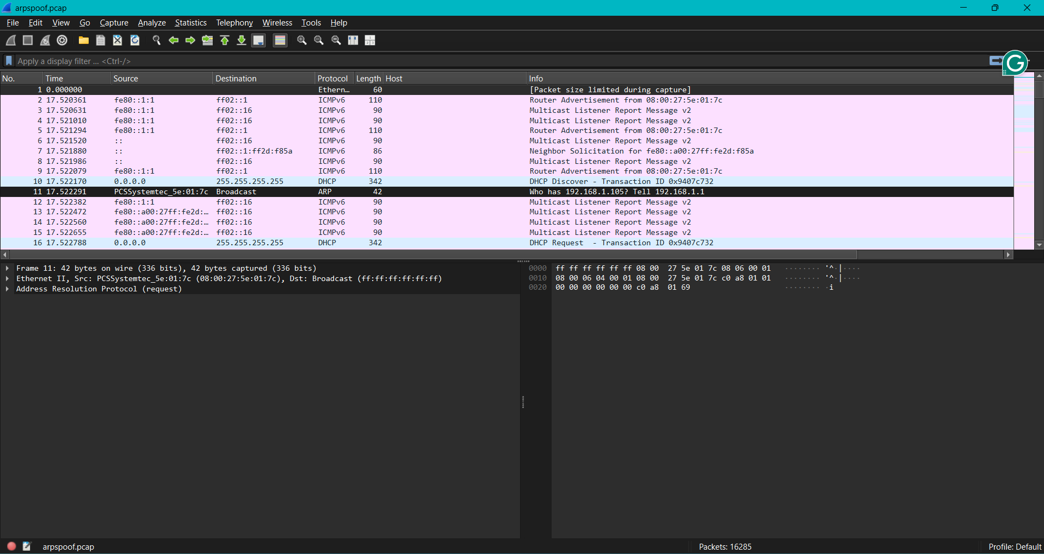

**Apply Filter : arp.opcode==2 & analyze MITM attack after spotting ARP Spoofing**

